‘I am the bread of life.’
Reading: John 6:48-51
Jesus said, “I am the bead of life. Long ago your people ate the manna in the desert, and they still died. But here is the bread that comes down from heaven. A person can eat it and not die. I am the living bread that came down from heaven. Everyone who eats some of this bread will live for ever. This bread is my body. I will give it for the life of the world.”

Thought about the reading
We all need food to help us live. Bread is a really important part of what we eat. In this country we have lots of different things to eat, but in some places if they did not have bread, they would die.
The people of Israel thought they would die when they were in the desert, after God had brought them out of Egypt. There was no food in the desert – no shops and nothing growing. They had no bread. God gave them special bread from heaven called ‘manna’. This appeared on the ground every morning and tasted like honey biscuits.
Jesus said that he was like the bread from heaven but even better! The people that ate manna died when they got old, but those that eat the living bread (Jesus) will live for ever. This does not mean that we will not die, but after that we will live forever in heaven with Jesus.
How can we eat Jesus? It is a way of saying that he should be the most important thing in our lives, even more important than the food we eat. He is the one who gives us life.

Prayer
Lord Jesus, thank you that you are like the bread from heaven, but even better. Thank you that when we die, we will live forever in heaven with you.
Dear Jesus, I want you to be the most important thing in my life. Help me to put you at the centre of everything I do.
Amen

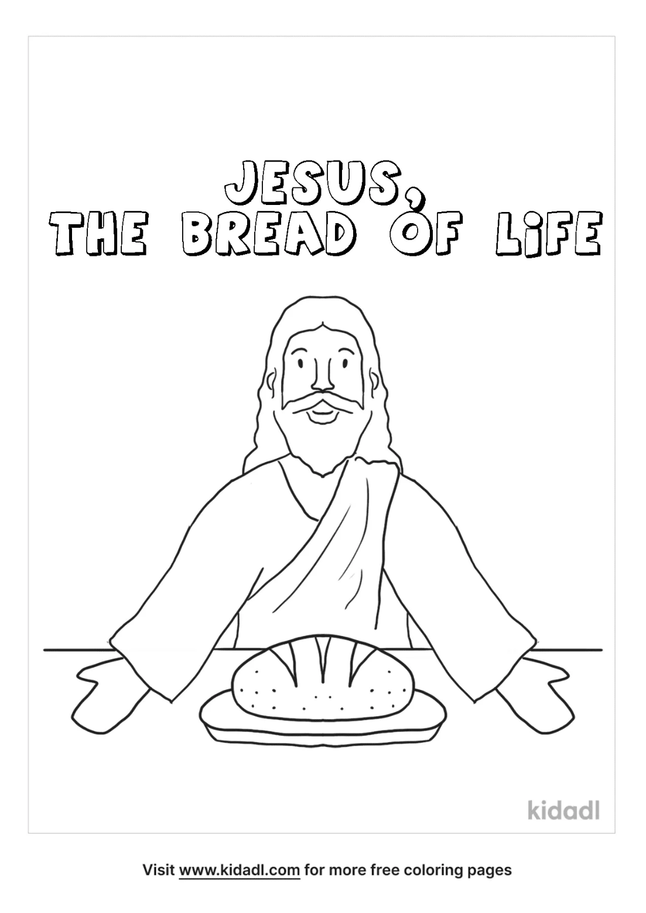

Cambridge Causeway

Autumn 2023
Bible Study notes

Jesus said ‘I am…’
- I am the bread of life
By Chrissy Cole

